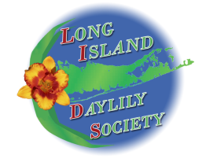
LONG ISLAND DAYLILY SOCIETY
MEMBERSHIP APPLICATION
LIDS Membership is from January 1st to December 31st

NAME:_____________________________________________________________

NAME OF DUAL MEMBER:_____________________________________________
ADDRESS:__________________________________________________________

CITY, STATE, ZIP_____________________________________________________

PHONE:_______________________EMAIL:________________________________
Type of LIDS Membership: □New □Renewal
LIDS Membership Desired: □Individual ($10)
□Dual ($15) (same household)
........................................................................................................................................................
Make FIRST check payable to LIDS
($10 for 1 year Individual membership, $15 for 1 year Dual membership)

Make a SECOND check payable to ADS
($25 for 1 year Individual membership, $30 for 1 year Dual membership)
PLEASE ENCLOSE TWO (2) MEMBERSHIP FORMS – LIDS & ADS.
If one check is sent as payment for both societies it will be returned to you.
Thank you for your cooperation.

To be a member of LIDS it is mandatory to have a membership in the American Hemerocallis Society (AHS).
Membership Deadline 12/1

Please mail check(s) and membership form(s) to:
Pat Klosowicz, Membership Chair
1635 Manatuck Blvd. Bayshore, NY 11706

Please check the appropriate box(es).

AHS Lifetime Member

AHS 3 Year Membership – expires on __________________

AHS Membership check mailed directly to AHS or PAID ONLINE at AHS

